Plumbing Apprenticeships Victoria and
CEPU - Plumbing Division (Vic)
Group Training Enterprise Agreement 2021
essential terms – cheat sheet

1 March 2023

What is its status?

Originally approved by the Fair Work Commission in 2019, the agreement was updated in 2021, and can be found by searching AG2021/6410 on the Fair Work Commission website.

Who does it apply to?

The agreement is special to PAV as a Registered Group Training Organisation and any apprentice employed by Master Plumbers.

It does not apply to other labour hire organisations, host employers or apprentices who are employed by others.

What are the pay rates in it?

There are 5 different pay rates that are applicable and relate to the conditions observed by the host employer where the apprentice is actually placed.

Apprentices are paid where they work, when they work there

- Minimum rate – applicable when placed at Host Employers who are not PPTEU Agreement Host Employers and at other times (see below). This is the base or foundation of employment conditions of apprentices and is paid for time when the apprentice is not placed or working on site with a Host Employer.
- Award + 10c per hour for ordinary time
- All apprentices are paid as if they have finished year 12

- Full PPTEU Agreement Host Employer Rate – wages and conditions align with the pattern EBA when placed with and working at the PPTEU Agreement Host Employer

- Partial PPTEU Agreement rates – when placed with a PPTEU Agreement Host Employer that has these in their own agreement – This is when an apprentice is placed on sites that are:
- commercial/industrial factory warehouse work or commercial residential unit industry work, as defined;
- or service and maintenance work as defined
It is expected that the partial category is used infrequently.

Interrelationship with the Training Contract

The employment conditions in the PAV EBA have been designed to work and align with the provisions in the Training Contract. This is a legally binding contract that contains obligations to be upheld by both the employer and the apprentice and the compliance of which is monitored by the VRQA.

The obligations are in the training contract executed on commencement of the apprenticeship. The key terms are summarised as follows:

- The Apprentice is to attend work, do the job offered and follow employer’s lawful instructions, working to achieve the qualification and diligently attend trade school
- Disputes are to be referred to the State Training Authority – VRQA
- Completion occurs when there is agreement between the employer, RTO and apprentice
- The Contract expires at the end of a nominal 4-year term unless it is extended
- The Employer is to provide on the job training opportunities aligned with achieving competencies in the training plan
- The Employer is to release the apprentice to attend Trade School and pay the wages and fees, following successful completion of each stage
The Training Contract can only be cancelled by mutual consent and if obligations cannot be met, it must be suspended.

During a period of suspension, the apprentice will be paid out entitlements until exhausted, workers compensation or income protection insurance – as are applicable. The apprentice will be placed on leave without pay where applicable for any balance of the duration of a suspension.

As the training contract is suspended, the apprentice will not progress in year levels during any period of suspension. The apprenticeship will recommence at the stage and year level where they left off.

Wage rates at Trade School

At the start of every month, the employer will run a report to show the amount of time an apprentice has been placed with an Award or Agreement Host Employer over the preceding 12 months (or part thereof). The rate payable is determined by where they have spent more than 50% of their time, regardless of any current placement.

Wage rates on Public Holidays

The wage rate payable is the rate of an apprentices last rate of pay immediately prior to a Public Holiday.

So: If an apprentice is placed with an Agreement Host Employer immediately prior to the Public Holiday – the Agreement Host Employer rate will apply.

If however an apprentice was placed with an Award Host Employer, on Downtime or other form of leave paying this rate, then the Award rate applies.

Cashing Out of Annual Leave

An apprentice must have 4 weeks remaining and can apply to cash out up to 2 weeks leave, once per 12-month period.

Close Down Period

A shut down period applies during Easter and Christmas/New Year. These are quiet times of year and apprentices are advised to use as much leave as possible at these times and take a break while the industry is quiet.

By agreement, apprentices can work during that time.

Accrual – Personal Leave
An Apprentice accrues where they work.

Sick leave is then paid – EBA Agreement Host Employer accrued leave first, then Award Host Employer second.

At the end of the apprenticeship, sick leave hours balance is reported to Incolink and becomes portable.

Evidence – Personal Leave/Compassionate Leave

Personal leave is only payable with the production of a medical certificate for any day of absence. These certificates must be from a treating medical practitioner and not a pharmacy or online document.

Compassionate Leave is also subject to the production of evidence.

Accrual Annual Leave and RDOs

An Apprentice accrues where they work.

Annual leave is then paid – EBA Agreement Host Employer accrued leave first, then Award Host Employer second.

Non - payment for refusal of services (reference to clause of PAV EBA)

20.4 The employer may, at its’ absolute discretion, temporarily decline the services of an apprentice who refuses to follow all reasonable and lawful directions regarding a placement with a Host Employer given by the employer. This means that an apprentice that:-

20.4.1 refuses a placement arranged by the employer; or
20.4.2 refuses a placement arranged by the employer for the apprentice by not attending the placement (without lawful cause); or
20.4.3 accepts a placement with a Host Employer, but then seeks to jeopardise the placement arranged by the employer for the apprentice; or
20.4.4 accepts a placement with a Host Employer, but is then returned by the Host Employer because of their attitude, performance, etc; or
20.4.5 does not make themselves readily available / contactable by the employer at any stage of their employment

may not be paid for so long as that apprentice refuses to follow that reasonable and lawful direction.

Non-Placement Time (reference to clause of PAV EBA)

An apprentice is entitled to 2 days paid downtime provided their conduct has not caused or contributed to the downtime occurring in accordance with clause 20.4. After that discussions will occur, and the employer and apprentice may reach agreement on one or more of the following outcomes:

35.5.2 As a result of the discussions provided in Clause 35.5.1, the employer and the apprentice may reach agreement on one (1) or more of the following outcomes:-

35.5.2(a) that the apprentice shall take accrued annual leave; and / or
35.5.2(b) that the apprentice shall take accrued RDO’s; and / or
35.5.2(c) that the apprentice shall take (in the absence of having accrued annual leave or accrued RDO’s) leave without pay; and / or
35.5.2(d) that the apprentice shall undertake training, which may include:-
• catching up on any outstanding modules or units of competence;
• undertaking module and / or units of competence re – sits;
• studying for module and / or units of competence re – sits;
• OH&S training;
• other training provided by the employer; and / or

35.5.2(e) that the apprentices’ apprenticeship shall be suspended for an agreed period of time.

Timesheet submission

Unless timesheets are signed by the Host Employer, the apprentice will not be paid. Deadline is Tuesday 10am.

Fares & Travel
The PAV EBA provides the circumstances on which Fares & Travel are payable as follows:

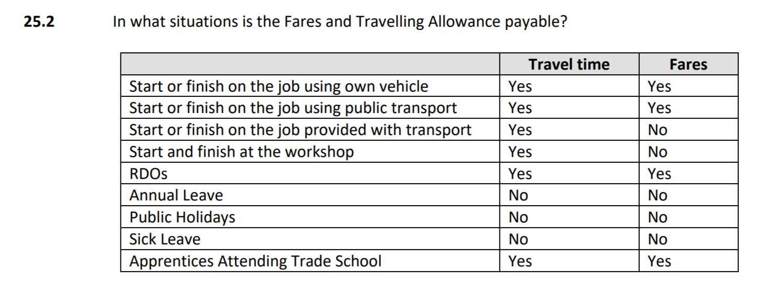

When on a PAV Minimum Rate, the distance from the Centre of Employment is 50kms to attract the standard allowance.

When on a PAV Agreement Host Employer Rate, the distance from the Centre of Employment is 75kms to attract the standard allowance.

The Centre of Employment is defined as follows:

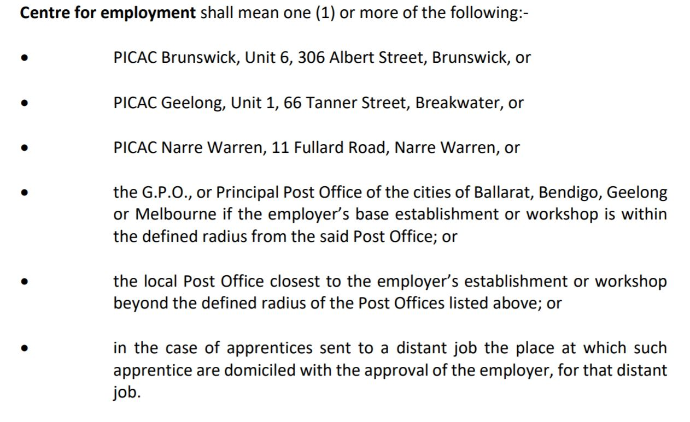

All apprentices will be allocated their centre of employment as above. Examples of the outcomes of this are as follows, the central ring is 50km radius, the outer ring is 75km radius.

PICAC Brunswick Centre of Employment

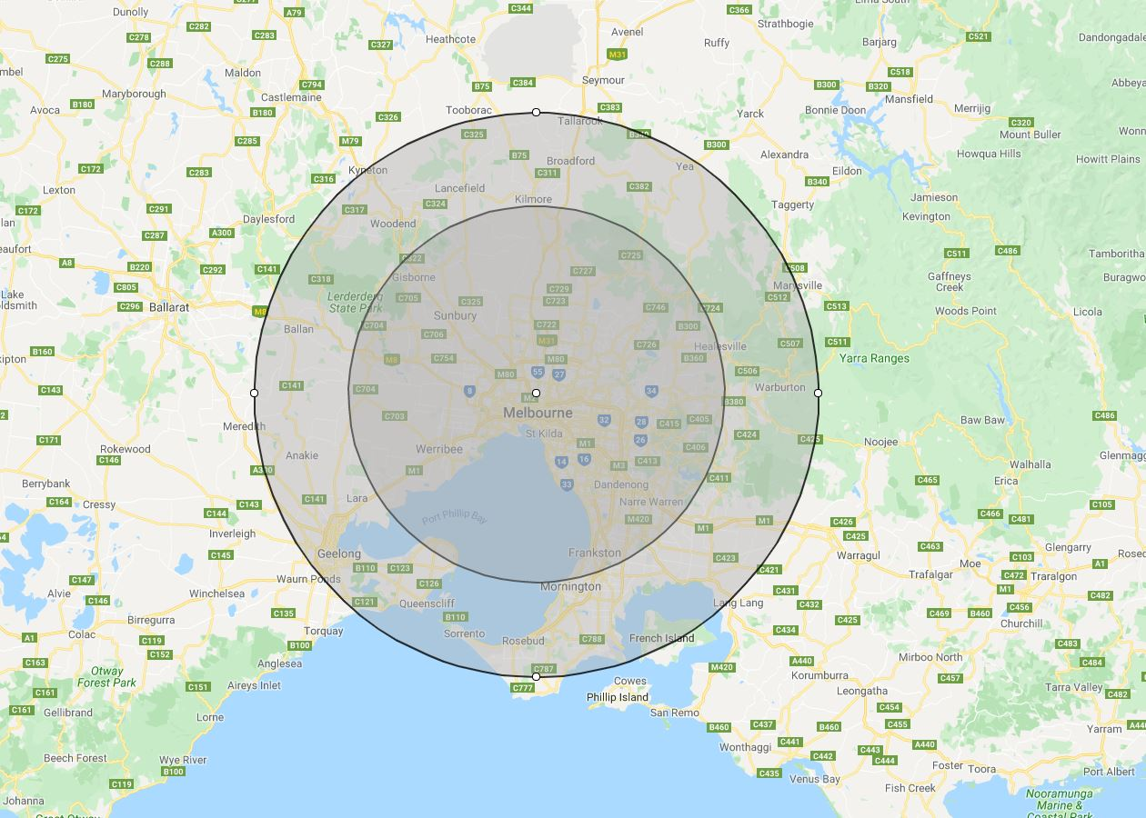

PICAC Narre Warren Centre of Employment

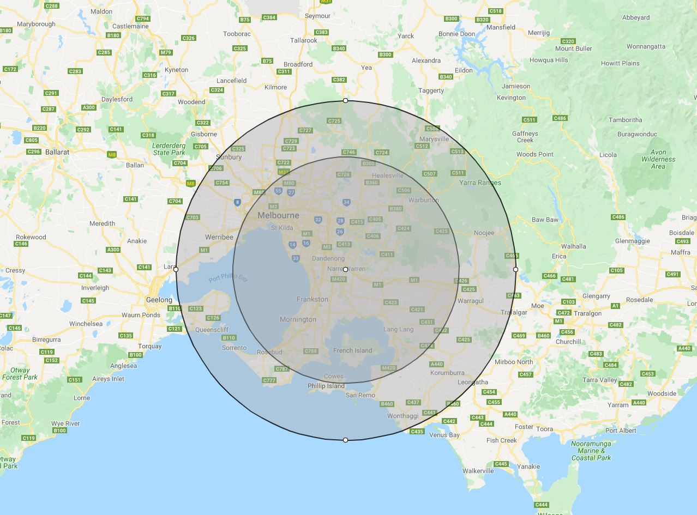

PICAC Geelong Centre of Employment

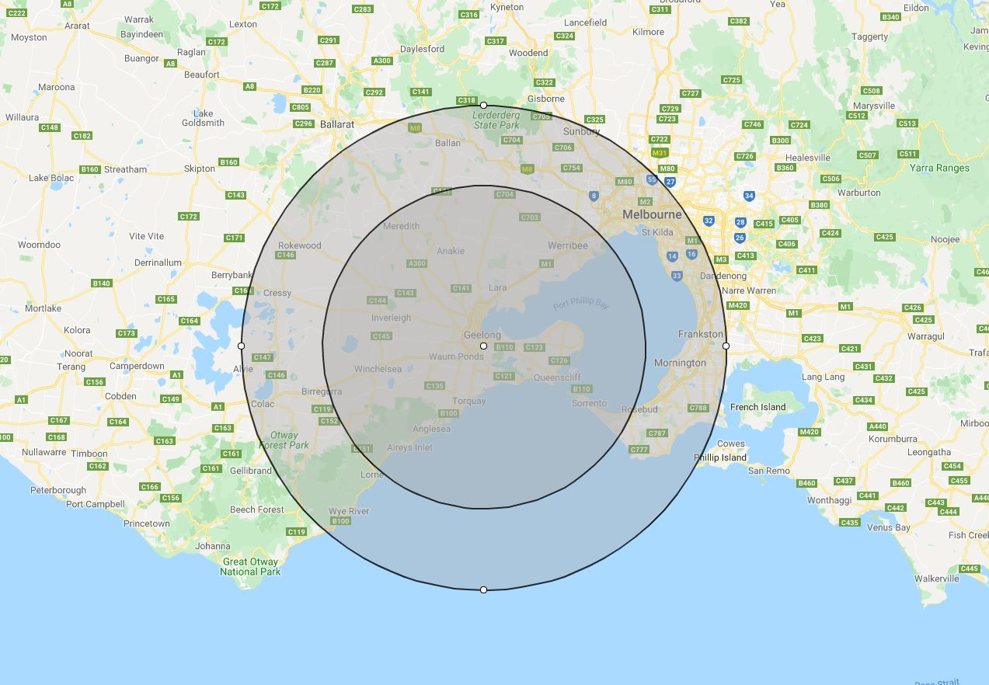

This change enables us to service a wider geography without disadvantaging apprentices that live in locations further away from the centre of Melbourne.

Plumbing Apprenticeships Victoria | Document Control Register EE011 Apprentice Wages & Conditions_Vic 010323 V1.5
Issue Date : 1 Mar 2023 | Scheduled Review Date : 1 Mar 2024
Version : 1.5 | Document Owner : GTS Manager

Rates of Pay - Hourly

Apprentice
Adult
AWARD – Apprentice 21 & Under at Commencement AWARD - Adult
AWARD
Type/Level | Hrs | 1 | 2 | 3 | 4 |  | Type/Level | Hrs | 1 | 2 | 3 | 4
Normal | 40 | 16.23 | 18.99 | 20.37 | 25.89 |  | Normal | 40 | 24.30 | 24.30 | 24.30 | 25.89
Fares | 5 | 15.81 | 15.81 | 15.81 | 15.81 |  | Fares | 5 | 15.81 | 15.81 | 15.81 | 15.81
Travel | 5 | 4.04 | 4.73 | 5.07 | 6.45 |  | Travel | 5 | 6.05 | 6.05 | 6.05 | 6.45
RDO Accrual | 2 | -16.23 | -18.99 | -20.37 | -25.89 |  | RDO Accrual | 2 | -24.30 | -24.30 | -24.30 | -25.89

EBA – Apprentice 21 & Under at Commencement EBA - Adult
EBA
Type/Level | Hrs | 1 | 2 | 3 | 4 |  | Type/Level | Hrs | 1 | 2 | 3 | 4
Normal | 40 | 20.16 | 28.94 | 36.32 | 46.20 |  | Normal | 40 | 24.25 | 28.94 | 36.32 | 46.20
Fares | 5 | 23.12 | 23.12 | 23.12 | 23.12 |  | Fares | 5 | 23.12 | 23.12 | 23.12 | 23.12
Travel | 5 | 5.04 | 7.24 | 9.08 | 11.55 |  | Travel | 5 | 6.06 | 7.24 | 9.08 | 11.55
RDO Accrual | 4 | -20.16 | -28.94 | -36.32 | -46.20 |  | RDO Accrual | 4 | -24.25 | -28.94 | -36.32 | -46.20

Rates of Pay - Weekly

Apprentice Adult

AWARD – Apprentice 21 & Under at Commencement AWARD - Adult
AWARD
Type/Level | 1 | 2 | 3 | 4 |  | Type/Level | 1 | 2 | 3 | 4
Normal | 616.74 | 721.62 | 774.06 | 983.82 |  | Normal | 923.40 | 923.40 | 923.40 | 983.82
Fares | 79.05 | 79.05 | 79.05 | 79.05 |  | Fares | 79.05 | 79.05 | 79.05 | 79.05
Travel | 20.20 | 23.65 | 25.35 | 32.25 |  | Travel | 30.25 | 30.25 | 30.25 | 30.25
RDO Accrual | -32.46 | -37.98 | -40.74 | -51.78 |  | RDO Accrual | -48.60 | -48.60 | -48.60 | -51.78
 | 683.53 | 786.34 | 837.72 | 1043.34 |  |  | 984.10 | 984.10 | 984.10 | 1041.34

EBA – Apprentice 21 & Under at Commencement EBA Adult
EBA
Type/Level | 1 | 2 | 3 | 4 |  | Type/Level | 1 | 2 | 3 | 4
Normal | 806.4 | 1157.60 | 1452.80 | 1848 |  | Normal | 970.00 | 1157.60 | 1452.80 | 1848
Fares | 115.60 | 115.60 | 115.60 | 115.60 |  | Fares | 115.60 | 115.60 | 115.60 | 115.60
Travel | 25.20 | 36.20 | 45.40 | 57.75 |  | Travel | 30.30 | 36.20 | 45.40 | 57.75
RDO Accrual | -80.64 | -115.76 | -145.28 | -184.80 |  | RDO Accrual | -97.00 | -115.76 | -145.28 | -184.80
 | 866.56 | 1193.64 | 1468.52 | 1836.55 |  |  | 1018.90 | 1193.64 | 1468.52 | 1836.55

